ASSIGNMENT NO.2
Basic Data Retrieval using SQL

Q1) Create a database named CollegeDB and a table named Student.
The table should contain the following columns:
Column Name Data Type StudentID StudentName INT VARCHAR(50) Age Course INT VARCHAR(30) City Marks VARCHAR(30) INT Add a primary key on StudentID and insert at least 10 records.

CREATE DATABASE WB_Ass2_CollegeDB2;
USE WB_Ass2_CollegeDB2;

CREATE TABLE Student (
StudentID INT PRIMARY KEY,
StudentName VARCHAR(50),
Age INT,
Course VARCHAR(30),
City VARCHAR(30),
Marks INT
);

INSERT INTO Student (StudentID, StudentName, Age, Course, City, Marks) VALUES
(1, 'Alice', 20, 'BSc', 'Mumbai', 85),
(2, 'Bob', 21, 'BCA', 'Pune', 78),
(3, 'Charlie', 19, 'BSc', 'Delhi', 92),
(4, 'Diana', 22, 'MCA', 'Mumbai', 88),
(5, 'Eve', 20, 'BCA', 'Nashik', 74),
(6, 'Frank', 21, 'BSc', 'Mumbai', 65),
(7, 'Grace', 19, 'MCA', 'Pune', 95),
(8, 'Heidi', 22, 'BCA', 'Delhi', 81),
(9, 'Ivan', 20, 'BSc', 'Mumbai', 89),
(10, 'Judy', 21, 'MCA', 'Nashik', 76);

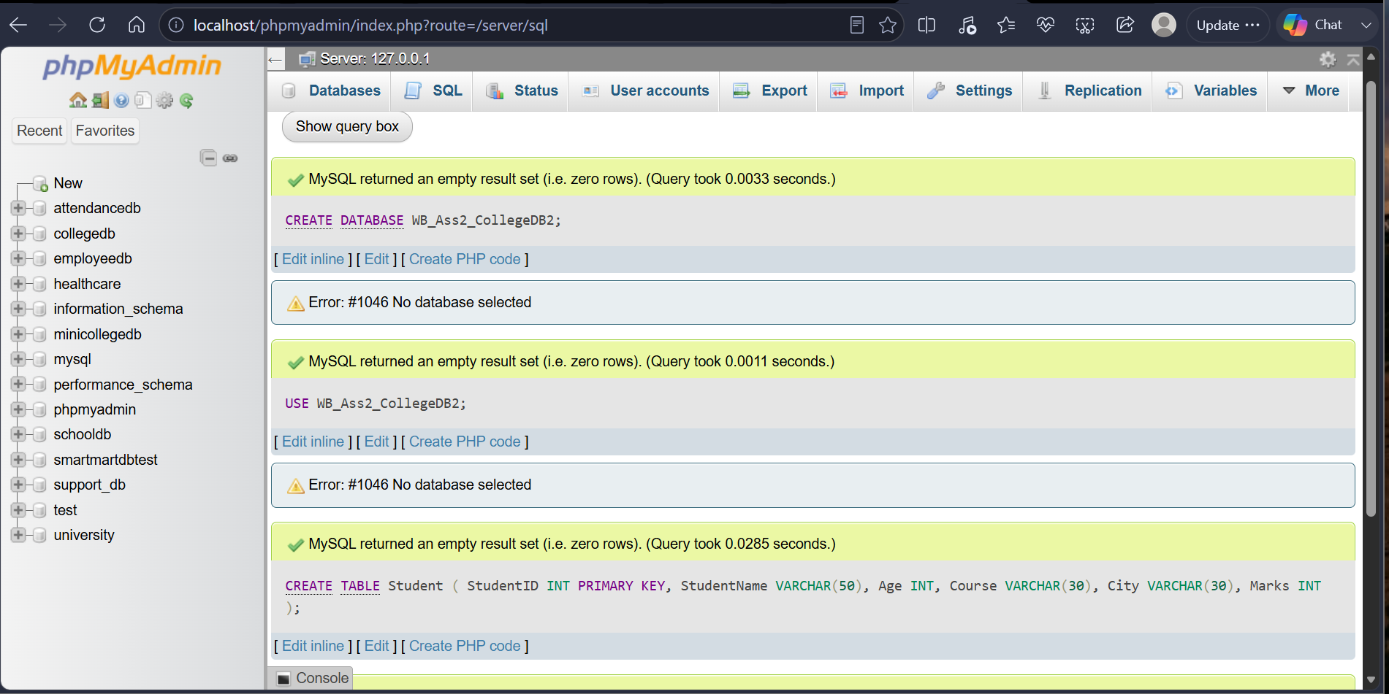

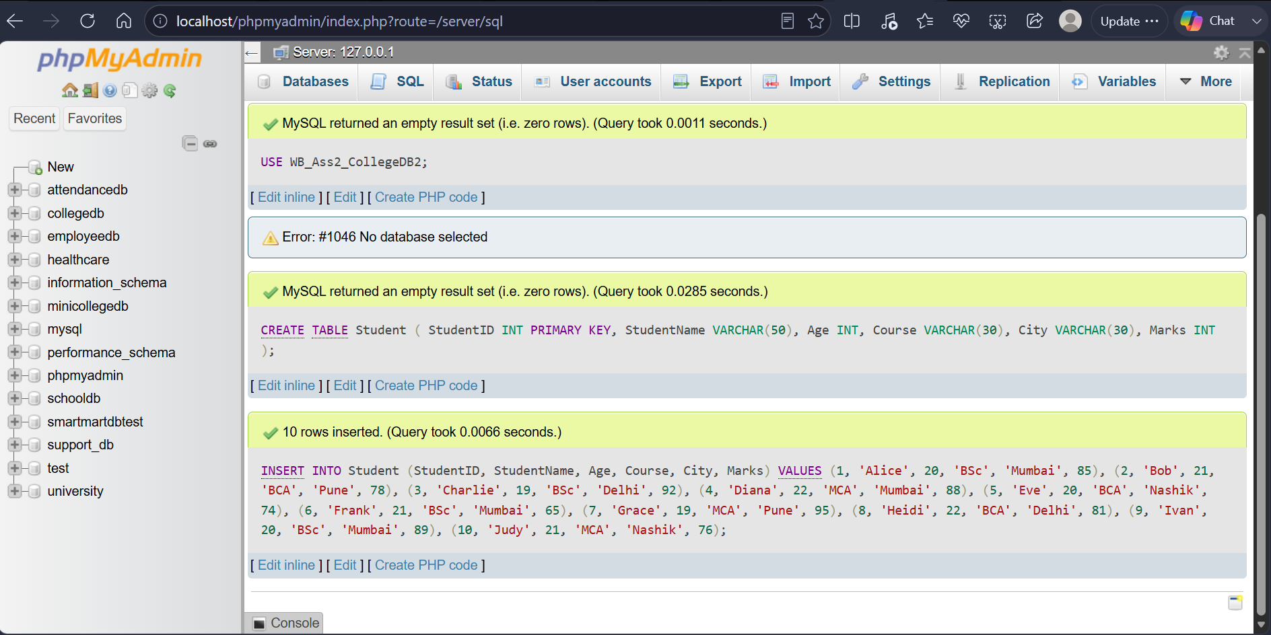

Q2) Write a MySQL query to display all records from the Student table.
The output should display all columns and all rows.

SELECT * FROM Student;

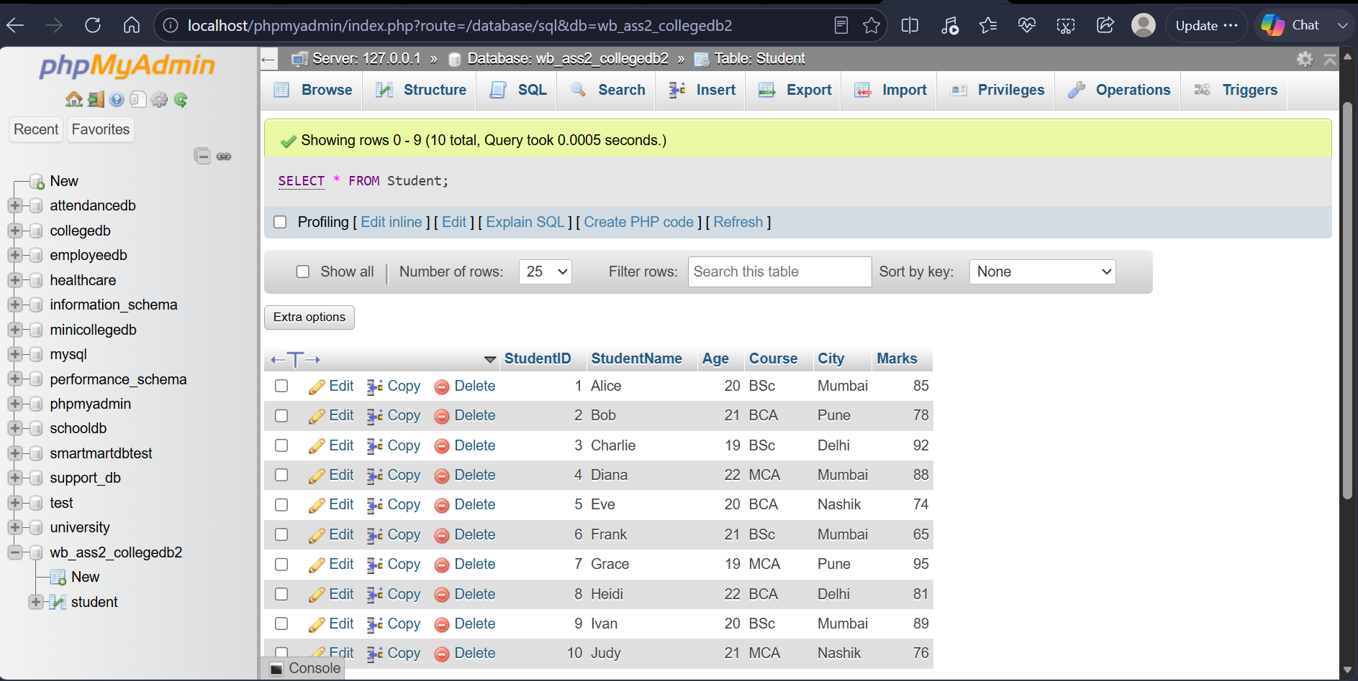

Q3) Write a MySQL query to display only the following columns:
1. StudentName 2. Course 3. City

SELECT StudentName, Course, City
FROM Student;

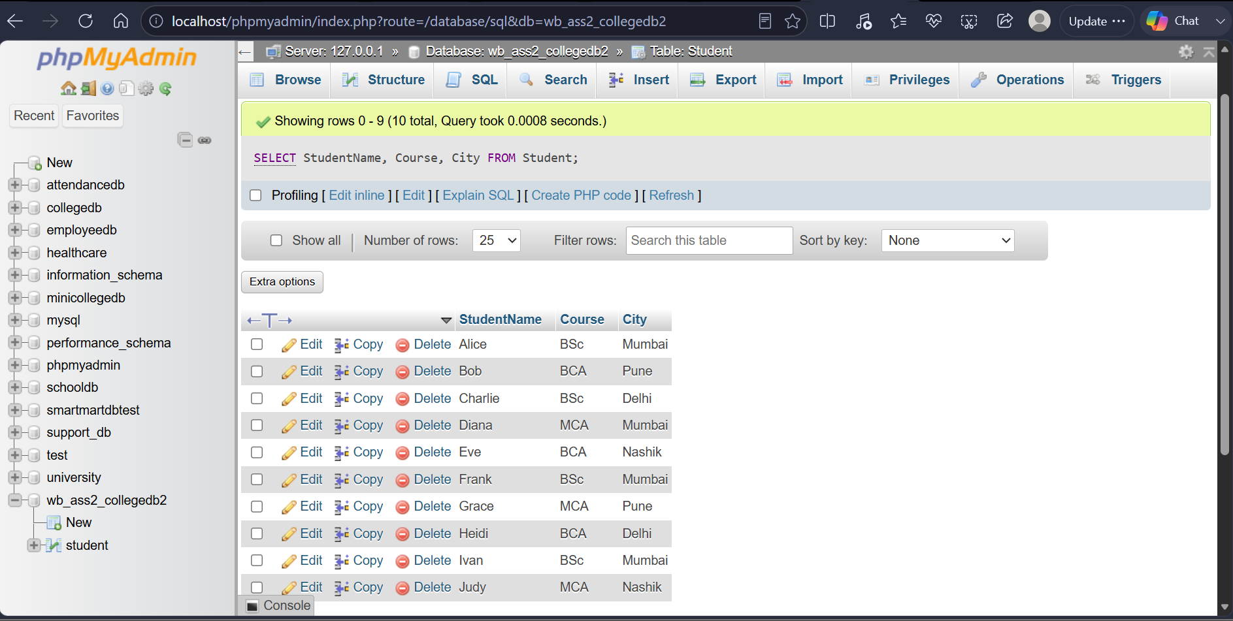

Q4) Write a MySQL query to display students who belong to the city Mumbai. The output should include:
1. StudentID 2. StudentName 3. City 4. Marks

SELECT StudentID, StudentName, City, Marks
FROM Student
WHERE City = 'Mumbai';

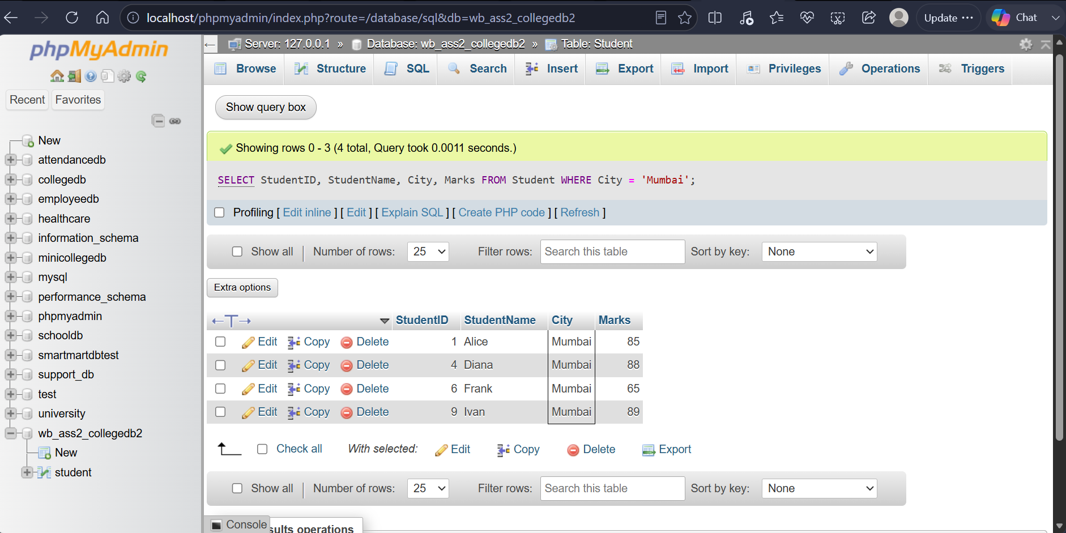
Q5) Write a MySQL query to display students whose marks are greater than 80.
21 B.SC. DATA SCIENCE The output should be sorted by marks in descending order.Select *

SELECT StudentName, Marks
FROM Student
WHERE Marks > 80
ORDER BY Marks DESC;

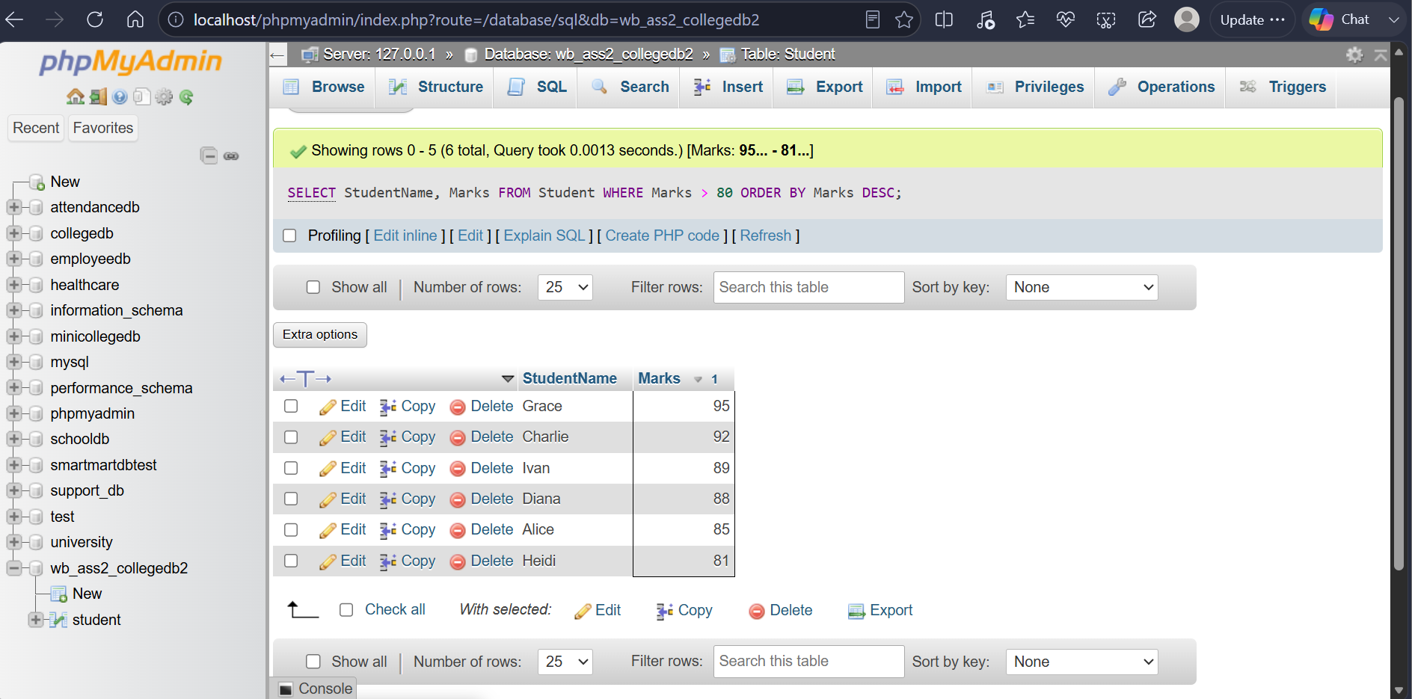

Q6) Write a MySQL query to display the top 3 students based on marks. The query should:
1. Display StudentName and Marks. 2. Sort marks from highest to lowest. 3. Display only 3 records using LIMIT.

Select studentName, Marks
From student
Order by Marks DESC
LIMIT 3;

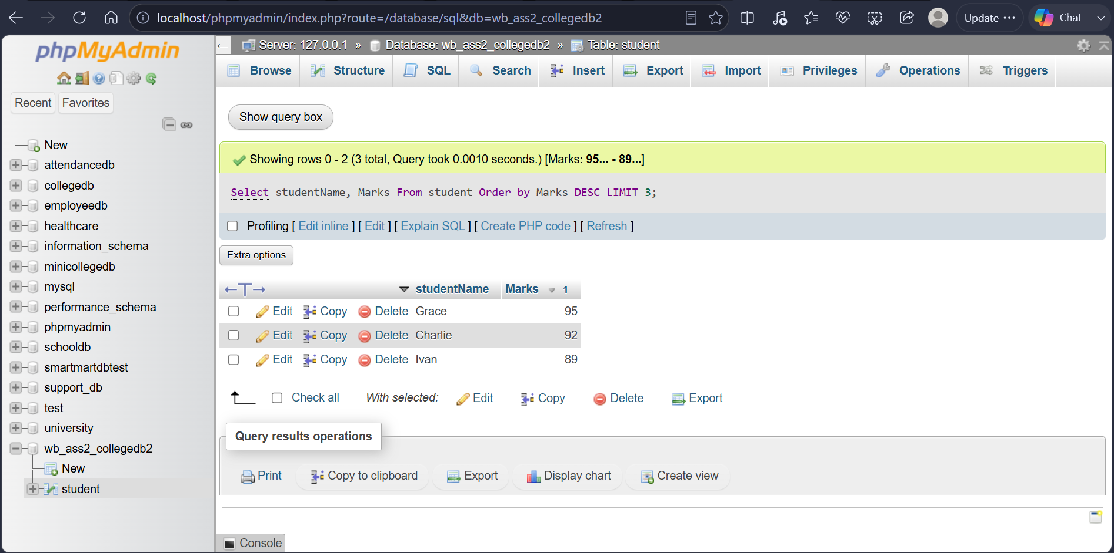

THANK YOU

